LANDSLIDE DETECTION AND COMMUNICATION NETWORKS

***Project Report submitted in partial fulfillment***

***of the requirement for the degree of***

**B.E (Electronics Engineering)**

Submitted By

ANIKET DOKE

MAYANK KASHYAP

VISHWAJIT LOKHANDE

SUSHANT GAJANKUSH

Under the Guidance of

Dr. SAURAV MITRA

Department of Electronics Engineering



Vidyalankar Institute of Technology

Wadala(E), Mumbai 400 037

## University of Mumbai

# 2015-16

### CERTIFICATE OF APPROVAL

**For**

**Project Work**

This is to Certify that

ANIKET DOKE

MAYANK KASHYAP

VISHWAJIT LOKHANDE

SUSHANT GAJANKUSH

Have successfully carried out Project work entitled

LANDSLIDE DETECTION AND COMMUNICATION NETWORKS

in partial fulfillment of degree course in

Electronics Engineering

As laid down by University of Mumbai during the academic year

2015-16

Under the Guidance of

Dr. SAURAV MITRA

Signature of Guide Head of Department

Examiner 1 Examiner 2 Principal

**Declaration**

We declare that this written submission represents our ideas in our own words and where others' ideas or words have been included, we have adequately cited and referenced the original sources. We also declare that we have adhered to all principles of academic honesty and integrity and have not misrepresented or fabricated or falsified any idea/data/fact/source in our submission. We understand that any violation of the above will be cause for disciplinary action by the Institute and can also evoke penal action from the sources which have thus not been properly cited or from whom proper permission has not been taken when needed.

Name of student Roll No. Signature

1. Aniket Doke 12103A0058

2. Mayank Kashyap 12103A0049

3. Vishwajit Lokhande 12103A0051

4. Sushant Gajankush 12103A0036

Date:

**Acknowledgement**

We have taken efforts in this project. However, it would not have been possible without the kind support and help of many individuals and professors. We would like to extend our sincere thanks to all of them. We are highly indebted to Dr. Saurav Mitra for their guidance and constant supervision as well as for providing necessary information regarding the project. We would like to express our gratitude towards our parents & members of Vidyalankar Institute of Technology for their kind co-operation and encouragement. Our thanks and appreciations also go to our colleagues in developing the project and people who have willingly helped us with their abilities and knowledge they possess.

**ABSTRACT**

Trains that pass through hilly regions often create a scenic visual although there are imminent dangers. In Konkan railways, out of an entire stretch of about 600kms, 30% comes under hilly regions. These are often prone to disasters like landslides etc. that are dangerous for trains. These regions are often lacking in proper communication media and therefore needs a disaster management solution.

 

As shown in the pictures, natural disasters can be very devastating. There is thus a dire need for a disaster management system involving fine engineering principles and logic. Train motormen often fail to see what is ahead because of fog, rains and night-time. Such cases have been reported in many countries and hilly regions face the worst problems. An upgraded control room will consist of state of the art technology. For intelligent decision making, three sensors viz, vibration sensor, moisture sensor and LED beam break sensor will detect the landslide and also track the train’s path and keep the control room informed of the position. Any calamity is immediately detected and reported on screen and quick action is taken. The control system should have minimal delay and must have no latency for effective control.

**TABLE OF CONTENTS**

* Introduction
* Aims and Objectives
* Literature Surveyed
* Problem Statement
* Scope
* Proposed System
* Methodology
* Analysis
* Process Model used for the project
* Feasibility Study
* Cost Analysis
* Design
* Data Flow Diagram
* UML/EER Diagram
* Hardware and Software Requirement

**1. PROJECT OVERVIEW**

Real-time monitoring of environmental disasters are one of the prime necessity of the world. Different technologies have been developed for this purpose. We have come up with a new concept wherein three sensors are used to predict as well as detect landslide occurrence in landslide prone areas.

Piezoelectric vibration sensor whose sensitivity can be adjusted according to vibrations taking place due to rocks is placed in the hilly region. This will help to predict landslide caused due to any seismic activity like earthquake.

Moisture sensor will act as an electrochemical cell which will measure moisture content in the soil which is one of the cause for landslide occurence as the contact between the soil loosens and results in avalanche.

LED beam break sensor will detect obstruction in its path eg. Falling of rocks prior to avalanche.

Just for intelligent decision making, atleast two sensors out of three should be active in order to avoid false alarm.

An alert message is given to Railway Control Room and is broadcasted on Facebook/Twitter page by interfacing GSM.

Railways can be informed about the landslide immediately by the nearby control room due to interconnected control rooms via RAILNET(Indian Railway’s Private Internet) and signaling system to avoid collision and saving lives.

**2. INTRODUCTION AND MOTIVATION**

**2.1 Theory (literature survey) behind the project concept**

**Motivation:**

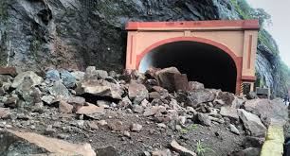



Vaibhavvadi Train Crash

52 people were killed in the crash and over 100 injured, including 26 in a critical state in Sindhudurg District, Maharashtra on 23 June 2003. The track had been covered by several large boulders earlier in the day from a landslide down the ravine's side, which had not been noticed due to the remote location. The rescue operation was difficult, because unlike with most Indian train accidents, local people did not see or hear the crash, and thus it was hours before the emergency services were notified. The cause of the crash was determined to have been rocks and earth, which tumbled onto the tracks ahead following a series of earth tremors, to which this area is especially prone.

**Technology used from then to avoid train accidents:**

**Anti-Collision Device (ACD):**

The Konkan Railway Corporation developed a new type of Anti Collision Device. The ACD Network is a train-collision prevention system invented by Mr. Rajaram Bojji and patented by the Konkan Railway

Corporation Limited, a public-sector undertaking of the Ministry of Railways, government of India. ACDs rely on GPS satellites for position updates. They exchange information through radio frequency transmissions to automatically brake and prevent collisions.

Loco ACDs brake to reduce the train speed to 15 km/h if on approach. They receive messages from each other ACDs on adjacent tracks. If inbound ACDs of other trains read 'train parted', the trains decelerate until they have stopped to prevent dangerous side collisions that can occur when adjacent tracks have been damaged.

**Latest Technologies Developed to Predict and Detect Landslides:**

**Fibre Optic Sensors:**

New technology may be able to predict when a landslide is imminent by detecting small shifts in soil, researchers in Italy say. Fiber-optic sensors embedded in shallow trenches within slopes could help detect and monitor both large landslides and slow slope movements. Usually, electrical sensors have been used for monitoring the risk of landslides, but these sensors can be easily damaged. Fiber-optic sensors are more robust, economical and sensitive. The fiber-optic sensors placed in the ground bend with any shift in the land mass and register the movement as a loss of light. Distributed optical fiber sensors can act as a ‘nervous system' of slopes by measuring the tensile strain of the soil they're embedded within.

**Wireless Sensor Networks:**

This design combines GSM wireless communication technology and wireless sensor network, it have completed the work from the system solution to the whole process of software and hardware design. The result proves that each node works stably and the status of network communication is good. This design can collect the depth of water in the mountain and the slope angle of the hillside, and provides the monitoring center with warning information in time, so related departments can take effective measures rapidly to protect people's lives and properties.

**2.2 Problem Definition/objectives**

To detect landslide using three sensors viz, vibration, moisture and led beam break sensors which are interfaced to microcontroller AT89S51 and to broadcast information of the same using social networking site by interfacing GSM.

Use of LED flood lights to highlight landslide affected area and buzzer alarm to alert railways at a particular distance.

**2.3 Need for project**

Since natural disasters are sudden, we have attempted a new concept to focus on landslide prediction and detection in landslide prone areas.

Due to lack of monitoring events in those areas, our project will help to keep continuous track of this disaster by using previously mentioned three sensors and to convey the information of the same to nearest control room so that quick actions can be taken.

**3. ANALYSIS AND DESIGN**

**3.1 Software/Hardware Development**

**Microcontroller AT89S51**

**Description:**

The AT89S51 is a low-power, high-performance CMOS 8-bit microcontroller with 4K bytes of In System Programmable Flash memory. The device is manufactured using Atmel’s high-density nonvolatile memory technology and is compatible with the industry- standard 80C51 instruction set and pin out. The on-chip Flash allows the program memory to be reprogrammed in-system or by a conventional nonvolatile memory programmer. By combining a versatile 8-bit CPU with In-System Programmable Flash on a monolithic chip, the Atmel AT89S51 is a powerful microcontroller which provides a highly-flexible and cost-effective solution to many embedded control applications. The AT89S51 provides the following standard features: 4K bytes of Flash, 128 bytes of RAM, 32 I/O lines, Watchdog timer, two data pointers, two 16-bit timer/counters, a

five-vector two-level interrupt architecture, a full duplex serial port, on-chip oscillator, and clock circuitry. In addition, the AT89S51 is designed with static logic for operation down to zero frequency and supports two software selectable power saving modes. The Idle Mode stops the CPU while allowing the RAM, timer/counters, serial port, and interrupt system to continue functioning. The Power-down mode saves the RAM contents but freezes the oscillator, disabling all other chip functions until the next external interrupt or hardware reset.

**Features:**

• Compatible with MCS®-51 Products

• 4K Bytes of In-System Programmable (ISP) Flash Memory

– Endurance: 10,000 Write/Erase Cycles

• 4.0V to 5.5V Operating Range

• Fully Static Operation: 0 Hz to 33 MHz

• Three-level Program Memory Lock

• 128 x 8-bit Internal RAM

• 32 Programmable I/O Lines

• Two 16-bit Timer/Counters

• Six Interrupt Sources

• Full Duplex UART Serial Channel

• Low-power Idle and Power-down Modes

• Interrupt Recovery from Power-down Mode

• Watchdog Timer

• Dual Data Pointer

• Power-off Flag

• Fast Programming Time

• Flexible ISP Programming (Byte and Page Mode)

• Green (Pb/Halide-free) Packaging Option

**Pin Diagram:**

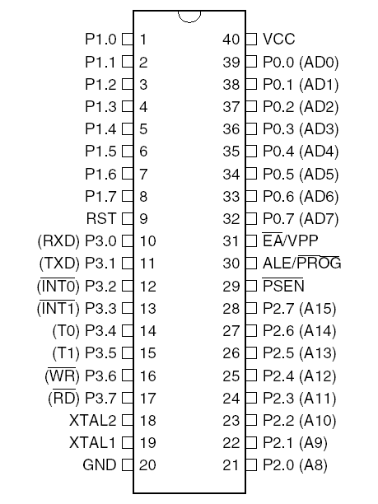

**Power Supply Design:**

Power supply is the first and the most important part of our project. For our project we require +5V regulated power supply with maximum current rating 500Ma.

Following basic building blocks are required to generate regulated power supply.

Regulated O/P

Voltage

Rectifier

Step-down transformer

Filter

Ckt.

Three

Terminal

Voltage req.

Mains 230 V A.C.

BLOCK DIAGRAM OF POWER SUPPLY

**Step Down Transformer:**

Step down transformer is the first part of regulated power supply. To step down the mains 230V A.C. we require step down transformer. Following are the main characteristic of electronic transformer.

1. Power transformers are usually designed to operate from source of low impedance at a single freq.
2. It is required to construct with sufficient insulation of necessary dielectric strength.
3. Transformer ratings are expressed in volt–amp. The volt-amp of each secondary winding or windings are added for the total secondary VA. To this are added the load losses.
4. Temperature rise of a transformer is decided on two well-known factors i.e. losses on transformer and heat dissipating or cooling facility provided unit.

**Rectifier Unit:**

Rectifier unit is a ckt. which converts A.C. into pulsating D.C. Generally semi-conducting diode is used as rectifying element due to its property of conducting current in one direction only. Generally there are two types of rectifier.

1. Half wave rectifier
2. Full wave rectifier.

In half wave rectifier only half cycle of mains A.C. is rectified so its efficiency is very poor. So we use full wave bridge type rectifier, in which four diodes are used. In each half cycle, two diodes conduct at a time and we get maximum efficiency at o/p.

Following are the main advantages and disadvantages of a full-wave bridge type rectifier ckt.

**Advantages:**

1. The need of center tapped transformer is eliminated.
2. The o/p is twice that of center tap circuit for the same secondary voltage.
3. The PIV rating of diode is half of the center tap circuit.

**Disadvantages:**

1. It requires four diodes.
2. As during each half cycle of A.C. input, two diodes are conducting therefore voltage drop in internal resistance of rectifying unit will be twice as compared to center tap circuit.

**Filter Circuit:**

Generally a rectifier is required to produce pure D.C. supply for using at various places in the electronic circuit. However, the o/p of rectifier has pulsating character i.e. if such a D.C. is applied to electronic circuit it will produce a hum i.e. it will contain A.C. and D.C. components. The A.C. components are undesirable and must be kept away from the load. To do so a filter circuit is used which removes (or filters out) the A.C. components reaching the load. Obviously a filter circuit is installed between rectifier and voltage regulator. In our project we use capacitor filter because of its low cost, small size and little weight and good characteristic. Capacitors are connected in parallel to the rectifier o/p because it passes A.C. but does not pass D.C. at all.

**Three terminal voltage regulator:**

A voltage regulator is a ckt. that supplies constant voltage regardless of change in load current. IC voltage regulators are versatile and relatively cheaper. The 7800 series consists of three terminal positive voltage regulator. These ICs are designed as fixed voltage regulator and with adequate heat sink, can deliver o/p current in excess of 1A. These devices do not require external component. This IC also has internal thermal overload protection and internal short circuit and current limiting protection. For our project we use 7805 voltage regulator IC.

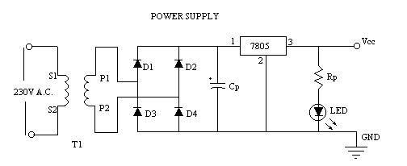

POWER SUPPLY CIRCUIT

**Design of Step Down Transformer:**

The following information must be available to the designer before he commences for the design of transformer.

1. Power Output.
2. Operating Voltage.
3. Frequency Range.

4)Efficiency and Regulation.

**Size of core:**

Size of core is one of the first considerations in regard of weight and volume of transformer. This depends on type of core and winding configuration used. Generally following formula is used to find area or size of core.

# P1

# Ai = ~~-----------~~

# 0.87

Ai = Area of cross - section in Sq. cm. and

P1 = Primary voltage.

In transformer P1 = P2

For our project we required +5V regulated output. So transformer secondary rating is 12V, 500mA.

So secondary power wattage is,

P2 = 12 x 500 x 10-3 w.

= 6w.

# 6

# So Ai =

# 0.87

= 2.62

Generally 10% of area should be added to core to accommodate all turns for low Iron losses and compact size.

So Ai = 2.88.

**Turns per volt:**

Turns per volt of transformer are given by relation

# 10,000

# Turns / Volt = ~~-----------------------~~

# 4.44 f Bm Ai

Here,

f is the frequency in Hz

Bm is flux density in Wb/m2

Ai is net area of cross section.

Following table gives the value of turns per volt for 50 Hz frequency.

|  |  |  |  |  |  |
| --- | --- | --- | --- | --- | --- |
| Flux density Wb/m2 | 1.14 | 1.01 | 0.91 | 0.83 | 0.76 |
| Turns per volt | 40/Ai | 45/Ai | 50/Ai | 55/Ai | 60/Ai |

TABLE : TURNS PER VOLT VALUES FOR 50 Hz.

Generally lower the flux density better be quality of transformer.

For project for 50 Hz the turns per Volt for 0.91 Wb/m2 from above table.

##### Turns per Volt = 50 / Ai

# 50

# =

# 2.88

≅ 17

Thus for Primary winding = 220 x 17 = 3800.

& for Secondary winding = 12 x 17 = 204.

**Wire size:**

As stated above size depends upon the current to be carried out by the winding, which depends upon current density of 3.1 A/mm2. For less copper losses 1.6 A/mm2 or 2.4 A/mm2 may be used. Generally even size gauge of wire are used.

**Rectifier Design:**

R.M.S. Secondary voltage at secondary of transformer is 12V.

So maximum voltage Vm across Secondary is

= Rms. Voltage x √2

= 12 x √2

= 16.97

D.C. O/p Voltage at rectifier O/p is

# 2 Vm

# Vdc = ~~----------~~

# π

2 x 16.97

= ~~-----------------------~~

π

= 10.80 V

PIV rating of each diode is

##### PIV = 2 Vm.

= 2 x 16.97

= 34 V

& maximum forward current which flow from each diode is 500mA.

So from above parameter we select diode IN 4007 from diode selection manual.

**Design of Filter Capacitor:**

Formula for calculating filter capacitor is,

# 1

# C = ~~----------------------~~

# 4√3 r f RL.

r = ripple present at o/p of rectifier.

(Which is maximum 0.1 for full wave rectifier.)

F = frequency of mains A.C.

RL = I/p impedance of voltage regulator IC.

# 1

# C = ~~------------------------------~~

# 4√3 x 0.1 x 50 x 28

= 1030 μf

≅ 1000 μf.

And voltage rating of filter capacitor is double of Vdc i.e. rectifier o/p which is 20V. So we choose 1000 μf / 25V filter capacitor.

# 

**IC 7805 (Voltage Regulator IC.):**

1 2 3 **Specifications:**



Available o/p D.C. Voltage = + 5V.

Line Regulation = 0.03

Load Regulation = 0.5

Vin maximum = 35 V

Ripple Rejection = 66-80 (db)

**Relay:**

The basis for relays, is the simple electromagnet

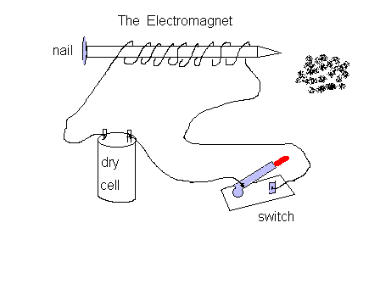

A nail, some wire, and a battery is all that is needed to make one, to demonstrate and Connect this to a power source, and it will now grab and hold small pieces of metal.

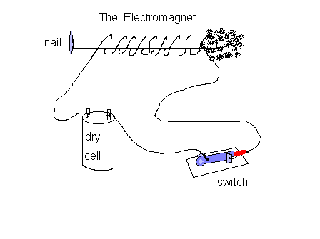

So, herein lies the concept. If we take an electromagnet, it will interact with metals in its vicinity. now lets take this one step further... If we were to place a piece of metal, near the electromagnet, and connect some contacts, so that when the electromagnet is energized, the contacts close, we have a working relay.

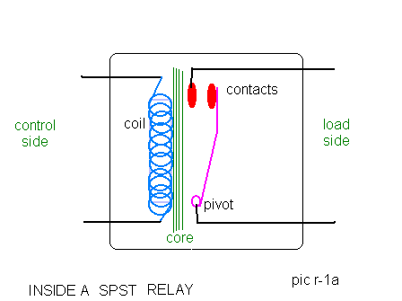

The simplest relay, is the Single Pole, Single Throw (spst) relay. It is nothing more than an electrically controlled on-off switch. It's biggest property, is the ability to use a very small current, to control a much larger current. this is desireable because we can now use smaller diameter wires, to control the current flow through a much larger wire, and also to limit the wear and tear on the control switch.

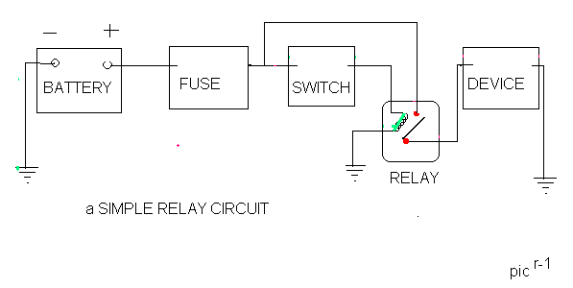

**Functioning:**

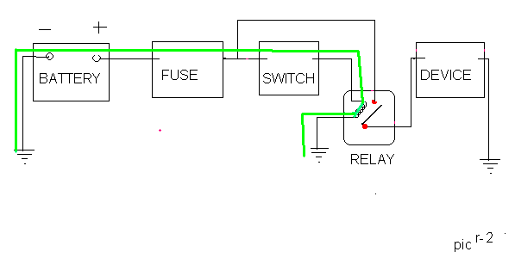

The control circuit (GREEN) powers the coil inside the relay, using a small amount of current. It flows from the battery, thru the fuse (for protection) to a switch, (say, a light switch) then to the coil in the relay, energizing it.

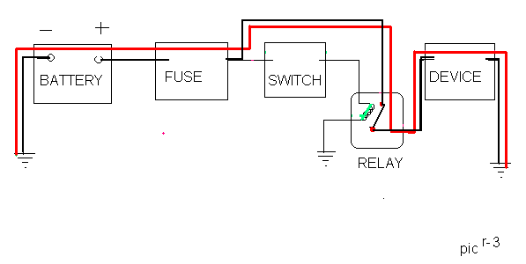

The coil, now energized becomes an electromagnet, and attracts the metal strip with the contacts, which closes, providing a secondary heavy current path (**RED**) to the device (say, the fog lights)

Turning off the switch, opens the circuit to the coil, removes current flow, and the electromagnet is no longer a magnet, the secondary path is opened, and the lights extinguish

**Relay Driver ULN2803:**

The eight NPN Darlington connected transistors in this family of arrays are ideally suited for interfacing between low logic level digital circuitry (such as TTL, CMOS or PMOS/NMOS) and the higher current/voltage requirements of lamps, relays, printer hammers or other similar loads for a broad range of computer, industrial, and consumer applications. All devices feature open–collector outputs and free wheeling clamp diodes for transient suppression.

The ULN2803 is designed to be compatible with standard TTL families while the ULN2804 is optimized for 6 to 15 volt high level CMOS or PMOS.

**Features:**

1. Eight darlingtons with common emitters;
2. Output current to 500 Ma;
3. Output voltage to 50 V;
4. Integral suppression diodes;
5. Versions for all popular logic families;
6. Output can be paralleled;
7. Inputs pinned opposite outputs to simplify board layout.

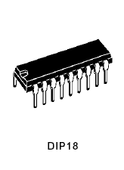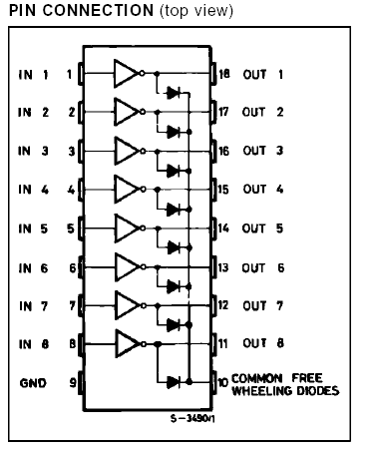

**Description:**

The ULN2801A-ULN2805A each contains eight Darlington transistors with common emitters and integral suppression diodes for inductive loads. Each Darlington features a peak load current rating of 600mA (500mA continuous) and can withstand at least 50V in the off state. Outputs maybe paralleled for higher current capability.

Five versions are available to simplify interfacing to standard logic families: the ULN2801A is designed for general purpose applications with a current limit resistor; the ULN2802A has a 10.5k input resistor and zener for 14-25V PMOS; the ULN2803A has a 2.7k input resistor for 5V TTL and CMOS; the ULN2804A has a 10.5k input resistor for 6-15V CMOS and the ULN2805A is designed to sink a minimum of 350mA for standard and Schottky TTL where higher output current is required. All types are supplied in an 18-lead plastic DIP with a copper lead from and feature the convenient input opposite-output pinout to simplify board layout.

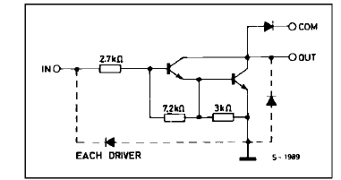

**Sensors:**

**Vibration (Piezo-Electric) Sensor:**

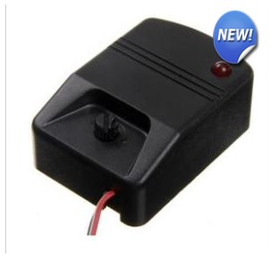

**Description:**  
This sensor buffers a piezoelectric transducer. As the transducer is displaced from the mechanical neutral axis, bending creates strain within the piezoelectric element and generates voltages.

**Specifications:**

The Vibration Sensor Detector is designed for the security practice When Vibration Sensor Alarm recognizes movement or vibration, it sends a signal to either control panel Developed a new type of omni-directional high sensitivity Security Vibration Detector with omni-directional detection

* Sensitivity: Height adjustable
* Consistency and Interchangeability: Good
* Reliability and Interference: Accurate triggering strong anti-interference
* Automatic Reset: Automatic reset is strong
* Signal Post-processing: Simple
* Output Signal: Switch signal
* No External Vibration Analysis of Plates: Product design vibration analysis of the internal amplifier circuit
* Detection Direction: Omni-directional
* Signal Output: Switch signals
* Output Pulse Width: The vibration signal amplitude is proportional to
* Operating Voltage: 12VDC (red V + shield V-)
* Sensitivity: Greater than or equal 0.2g
* Frequency Range: 0.5HZ ~ 20HZ
* Operating Temperature Range: -10 ? ~ 50

**Connections details - How to test Vibration sensor?**

* **Wiring colour ---------**
* **RED - + 5 - 12 volts**
* **BLACK - GND**
* **OUTPUT - connect common Red - Blue Output**

**To test Led - Connect Anode to Red Cathode to Blue - while vibration led Goes On and off for 1 sec**

**Water Level (Moisture) Sensor:**

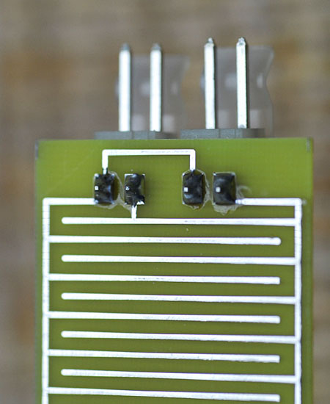

|  |
| --- |
|  |

**Water Level Sensor Product Description**:

Global Water's WL400 Water Level Sensor provides highly accurate water level measurement for a wide variety of applications, including those in severe environments.  The submersible pressure transducers have a dynamic temperature compensation system, enabling high accuracy measurements over a wide temperature range.  The water level sensor is easily adapted to all dataloggers, telemetry, monitoring equipment, and displays.

Each of the water level sensors consist of a solid state submersible pressure transducer encapsulated in a stainless steel 13/16" diameter housing.  The water level sensor has a molded-on waterproof cable and a two-wire 4-20 mA high level output for connection to a monitoring device.  A 25' cable is standard, and optional cable lengths are available up to 500'.

The Water Level Sensor's submersible pressure transducer is fully encapsulated with marine-grade epoxy so that moisture can never leak in or work its way down the vent tube to cause drift or level sensor failure (as is the case with other pressure sensors).  The water level sensor uses a unique, highly flexible silicon diaphragm to interface between water and the sensing element.  This silicon diaphragm protects the water level sensor's electronics from moisture and provides each sensor with exceptional linearity and very low hysteresis.  The design of the submersible pressure transducers eliminates the issues associated with metal foil diaphragms, which tend to crinkle and stretch out over time causing drift, linearity, and hysteresis problems.  The water level sensor is also has [automatically barometric compensation](http://www.globalw.com/support/barocomp.html) due to the attached vent cable and protected by a stainless steel micro-screen cap, which makes fouling with silt, mud, or sludge virtually impossible.  The water level sensor's design is great for all saltwater applications including tide level monitoring, floating docks, and others.

**LED Beam Bream Sensor:**

**Photo Detector:**

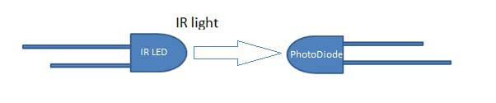

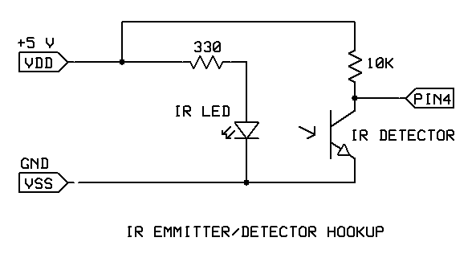

A junction photodiode is an intrinsic device that behaves similarly to an ordinary signal diode, but it generates a photocurrent when light is absorbed in the depleted region of the junction semiconductor. A photodiode is a fast, highly linear device that exhibits high quantum efficiency based upon the application and may be used in a variety of different applications.

It is necessary to be able to correctly determine the level of the output current to expect and the responsivity based upon the incident light.

Use an IR LED and phototransistor pair to create a light beam switch. Point the components at each other to turn the switch on, then break the beam to turn the switch off. Use to detect when of your machine passes by a particular point. Or, bounce the light from the diode off a part to reflect back onto the detector. If the part is there, light will reach the detector and the signal can be passed to your Stamp.

**GSM Module - SIM900:**

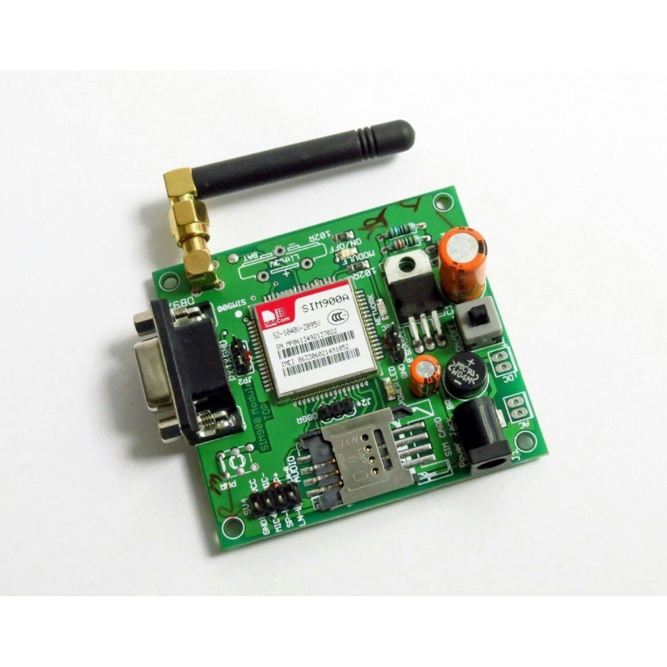

GPRS module is a breakout board and minimum system of SIM900 Quad-band/SIM900A Dual-band GSM/GPRS module. It can communicate with controllers via AT commands (GSM 07.07 ,07.05 and SIMCOM enhanced AT Commands). This module supports software power on and reset.

**Features:**

* Quad-Band 850/ 900/ 1800/ 1900 MHz
* Dual-Band 900/ 1900 MHz
* GPRS multi-slot class 10/8GPRS mobile station class B
* Compliant to GSM phase 2/2+Class 4 (2 W @850/ 900 MHz)
* Class 1 (1 W @ 1800/1900MHz)
* Control via AT commands (GSM 07.07 ,07.05 and SIMCOM enhanced AT Commands)
* Low power consumption: 1.5mA(sleep mode)
* Operation temperature: -40°C to +85 °C